**DAILY ONLINE ACTIVITIES SUMMARY**

|  |  |  |  |  |  |  |  |  |
| --- | --- | --- | --- | --- | --- | --- | --- | --- |
| **Date:** | **22-05-2020** | | | | | **Name:** | **Samrin banu** | |
| **Sem & Sec** | **8th sem B sec** | | | | | **USN:** | **4AL16CS082** | |
| **Online Test Summary** | | | | | | | | |
| **Subject** | | **BDA** | | | | | | |
| **Max. Marks** | | **40** | | **Score** | | | **29** | |
| **Certification Course Summary** | | | | | | | | |
| **Course** | **Introduction to hadoop** | | | | | | | |
| **Certificate Provider** | | | **Great learning website** | | **Duration** | | | **10-12.30** |
| **Coding Challenges** | | | | | | | | |
| **Problem Statement:** Find the number that is missing from the array containing n distinct number taken from 0,1,2....n | | | | | | | | |
| **Status: completed** | | | | | | | | |
| **Uploaded the report in Github** | | | | | **yes** | | | |
| **If yes Repository name** | | | | | **Samrinbanu** | | | |
| **Uploaded the report in slack** | | | | | **yes** | | | |

Online Test Details: (Attach the snapshot and briefly write the report for the same)

Test was good and was not able to see the platform properly as the platform was not that good

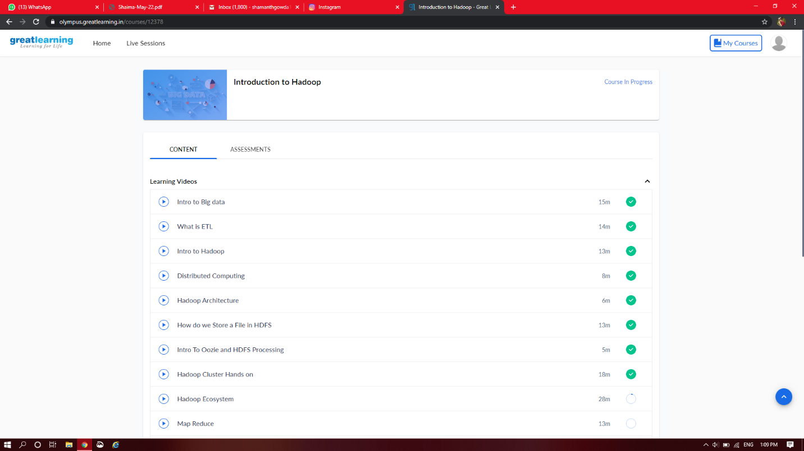

Certification Course Details: (Attach the snapshot and briefly write the report for the same)

Saw videos related to Hadoop n introduction was given to haddop about using Hadoop

**What is distribution computing?**

Distributed computing is a model in which components of a software system are shared among multiple computers to improve efficiency and performance.

The Distributed Computing Environment (DCE) is a widely-used industry standard that supports this kind of distributed computing. On the Internet, third-party service providers now offer some generalized services that fit into this model. One of the first uses of grid computing was the breaking of a cryptographic code by a group that is now known as distributed.net. That group also describes its model as distributed computing.

**Hadoop Architecture**

Apache Hadoop offers a scalable, flexible and reliable distributed computing big data framework for a cluster of systems with storage capacity and local computing power by leveraging commodity hardware. Hadoop follows a Master Slave architecture for the transformation and analysis of large datasets using Hadoop MapReduce paradigm.

The 3 important hadoop components that play a vital role in the Hadoop architecture are -

• Hadoop Distributed File System (HDFS) – Patterned after the UNIX file system

• Hadoop MapReduce

• Yet Another Resource Negotiator (YARN

Coding Challenges Details: (Attach the snapshot and briefly write the report for the same)

Coding was given n it was uploaded for github and slack

PROGRAM1

#include stdio.h

int getMissingNo(int a[], int n)

{

int i, total;

total = (n + 1) * (n + 2) / 2;

for (i = 0; i < n; i++)

total -= a[i];

return total;

}

int main()

{

int a[] = { 1, 2, 4, 5, 6 };

int miss = getMissingNo(a, 5);

printf("%d", miss);

getchar();

}